**ALAGAPPA COLLEGE OF TECHNOLOGY**

**ANNA UNIVERSITY-600025**

**NAAN MUDHALVAN ASSIGNMENT**

**DIGITAL MARKETING**

**Name:** Yugadharshini A

**Roll No:** 2020308036

**Department:** B. Tech Pharmaceutical Technology

**College:** Alagappa College of Technology, Anna University.

**Naan Mudhalavan ID:au2020308036**

**Zone:** Zone-1

**GitHub Link:** [**https://github.com/JebinDanielR/NaanMudhalvan-DigitalMarketing-BrandLogo**](https://github.com/JebinDanielR/NaanMudhalvan-DigitalMarketing-BrandLogo)

**Assignment-1:**

Create a company name and design a poster and logo for that company.

Company Name: The Relish Cafe

Company Description: Best Food at an Affordable Cost

Company Type: Restaurant

Logo:



Poster:



**Assignment-2:**

Create a blog describing about your company.

Blog Link:

<https://trcafeoffers.blogspot.com/>



**Assignment-3:**

Create a Facebook account for your company

Facebook ID:

<https://www.facebook.com/TheRelishCafe>

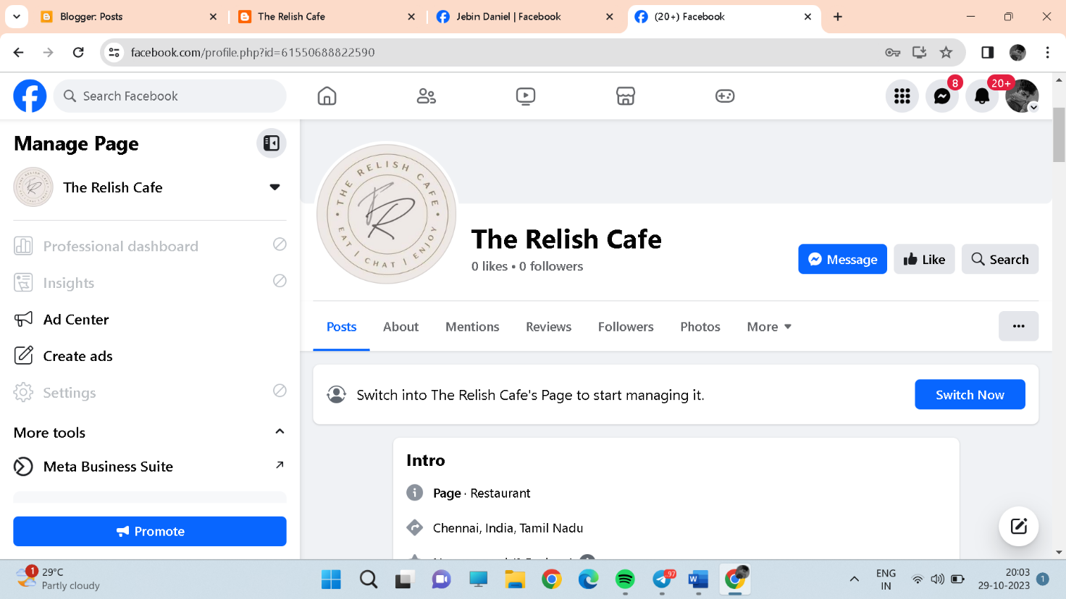

**Assignment-4:**

Create an Email Newsletter for your company and post it in your company blog site. Do google analytics for you blog and send google analytics id.

Google Analytics Measurement ID: G-RRFD3XTTPR

Email Newsletter link:https://trcafeoffers.blogspot.com/2023/10/email-newsletter.html

